**RDBMS First Foundation Evaluation SET 1**

**Q 1.1**

**CREATE TABLE Shops (**

**ShopID INT PRIMARY KEY,**

**ShopName VARCHAR(255) NOT NULL**

**);**

**INSERT INTO Shops (ShopID, ShopName)**

**VALUES**

**(1, 'Amal Stores'),**

**(2, 'Jyothi Stores'),**

**(3, 'Indira Stores');**

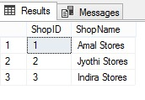

**CREATE TABLE Items (**

**ItemID INT PRIMARY KEY,**

**ItemName VARCHAR(255) NOT NULL**

**);**

**INSERT INTO Items (ItemID, ItemName)**

**VALUES**

**(1, 'Bar-One'),**

**(2, 'KitKat'),**

**(3, 'MilkyBar'),**

**(4, 'Munch');\**

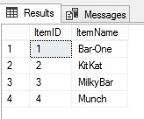

**CREATE TABLE SaleDates (**

**SaleDateID INT PRIMARY KEY,**

**SaleDate DATE NOT NULL**

**);**

**INSERT INTO SaleDates (SaleDateID, SaleDate)**

**VALUES**

**(1, '2018-10-05'),**

**(2, '2018-10-10'),**

**(3, '2018-09-15');**

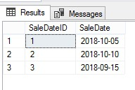

**CREATE TABLE Sales (**

**SaleID INT PRIMARY KEY,**

**SaleDateID INT,**

**ShopID INT,**

**ItemID INT,**

**Quantity INT,**

**UnitPrice DECIMAL(10, 2),**

**FOREIGN KEY (SaleDateID) REFERENCES SaleDates (SaleDateID),**

**FOREIGN KEY (ShopID) REFERENCES Shops (ShopID),**

**FOREIGN KEY (ItemID) REFERENCES Items (ItemID)**

**);**

**INSERT INTO Sales (SaleID, SaleDateID, ShopID, ItemID, Quantity, UnitPrice)**

**VALUES**

**(1, 1, 1, 1, 100, 10.00),**

**(2, 1, 1, 2, 200, 15.00),**

**(3, 1, 1, 3, 50, 5.00),**

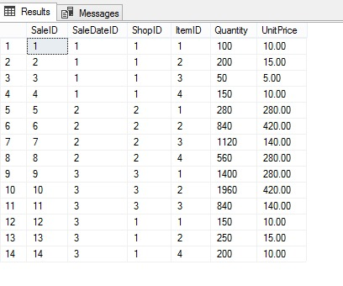 **(4, 1, 1, 4, 150, 10.00),**

**(5, 2, 2, 1, 10 * 28, 280.00),**

**(6, 2, 2, 2, 30 * 28, 420.00),**

**(7, 2, 2, 3, 40 * 28, 140.00),**

**(8, 2, 2, 4, 20 * 28, 280.00),**

**(9, 3, 3, 1, 50 * 28, 280.00),**

**(10, 3, 3, 2, 70 * 28, 420.00),**

**(11, 3, 3, 3, 30 * 28, 140.00),**

**(12, 3, 1, 1, 150, 10.00),**

**(13, 3, 1, 2, 250, 15.00),**

**(14, 3, 1, 4, 200, 10.00);**

**Q 1.2**

**SELECT TOP 1**

**I.ItemName,**

**SUM(S.Quantity * S.UnitPrice) AS Revenue**

**FROM**

**Sales S**

**JOIN SaleDates SD ON S.SaleDateID = SD.SaleDateID**

**JOIN Items I ON S.ItemID = I.ItemID**

**WHERE**

**MONTH(SD.SaleDate) = 10**

**GROUP BY**

**I.ItemName**

**ORDER BY**

**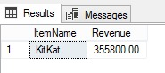    Revenue DESC**

Q 1.3

SELECT TOP 1

I.ItemName,

SUM(S.Quantity) AS TotalQuantity

FROM

Sales S

JOIN SaleDates SD ON S.SaleDateID = SD.SaleDateID

JOIN Items I ON S.ItemID = I.ItemID

JOIN Shops SH ON S.ShopID = SH.ShopID

WHERE

MONTH(SD.SaleDate) = 10

AND SH.ShopName = 'Amal Stores'

GROUP BY

I.ItemName

ORDER BY

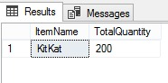 TotalQuantity DESC

Q 1.4

SELECT

I.ItemName,

SUM(S.Quantity * S.UnitPrice) AS Revenue

FROM

Sales S

JOIN SaleDates SD ON S.SaleDateID = SD.SaleDateID

JOIN Items I ON S.ItemID = I.ItemID

WHERE

MONTH(SD.SaleDate) = 10

GROUP BY

I.ItemName

HAVING

SUM(S.Quantity * S.UnitPrice) > 10000

ORDER BY

    Revenue DESC

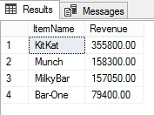

Q 1.5

SELECT

SH.ShopName,

SUM(S.Quantity * S.UnitPrice) AS Revenue

FROM

Sales S

JOIN SaleDates SD ON S.SaleDateID = SD.SaleDateID

JOIN Shops SH ON S.ShopID = SH.ShopID

WHERE

MONTH(SD.SaleDate) = 10

GROUP BY

SH.ShopName

ORDER BY

    Revenue DESC

